COMPUTER SCIENCE 2 REPORT: S4692/0650
QUESTION 1:
- Source code
#include <iostream>
#include <string>
#include <iomanip>
using namespace std;

const double MIN_BALANCE = 50000;

class Account {
private:
int accNumber;
string holderName;
double balance;

public:
Account(int number, string holder, double bal) : accNumber(number), holderName(holder), balance(bal) {}

void info()
{
cout << "\n----- INFO FOR USER ACCOUNT #" << getAccNumber() << " -----" << endl
<< "Account holder name: " << getHolderName() << endl
<< "Balance: " << setprecision(9) << getBalance() << " TZS" << endl << endl;
}

const int getAccNumber() {
return accNumber;
}

const string getHolderName() {
return holderName;
}

const double getBalance() {
return balance;
}
};

int main()
{
cout << showpoint;

// Create 5 entries for accounts
Account acc1(1, "Jonathan Cash", 2000000.0);
Account acc2(2, "Maria Donnie", 50000.0);
Account acc3(3, "Brendan Christopher", 450000.0);
Account acc4(4, "Benjamin Tennyson", 10000000.0);
Account acc5(5, "Raphael Benedict", 950000.0);

// Gather entries into an array
Account accounts[] = {acc1, acc2, acc3, acc4, acc5};

cout << "********** WELCOME TO THE BANK ACCOUNT MANAGEMENT SYSTEM **********" << endl
<< "\nSelect an option from below" << endl
<< "1. Check account\n2. Lowest asset profile\n3. Exit\n\nYour choice: ";
int choice;
cin >> choice;

switch(choice) {
case 1: {
// Prompt for and search for user account
cout << "\n1. CHECK ACCOUNT" << endl
<< "Enter account number to search for: ";
int number;
cin >> number;

if (number <= 0 || number > 5) {
cout << "\nAccount non existent!\n" << endl;
} else {
accounts[number - 1].info();
}
break;
}

case 2: {
cout << "\n2. LOWEST ASSET PROFILE\n";

// Loop thru items to identify the one with the absolute minimum balance requirement
for (int i = 0; i < 5; ++i) {
if (accounts[i].getBalance() == MIN_BALANCE) {
cout << "\nDetails for account with minimum balance requirement (50,000 TZS)....." << endl;
accounts[i].info();
}
}
break;
}

case 3: {
cout << "\nExiting program..." << endl;
return 0;
break;
}

default: {
cout << "Invalid option selected." << endl;
break;
}
}

return 0;
}

- Screenshots
- Selecting the “check account” option
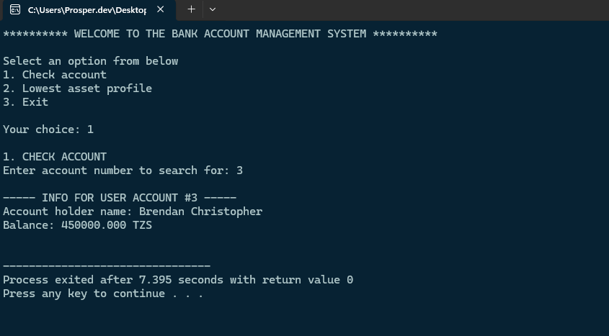

- Selecting the “lowest asset profile”option
Index Number: S4692/0650
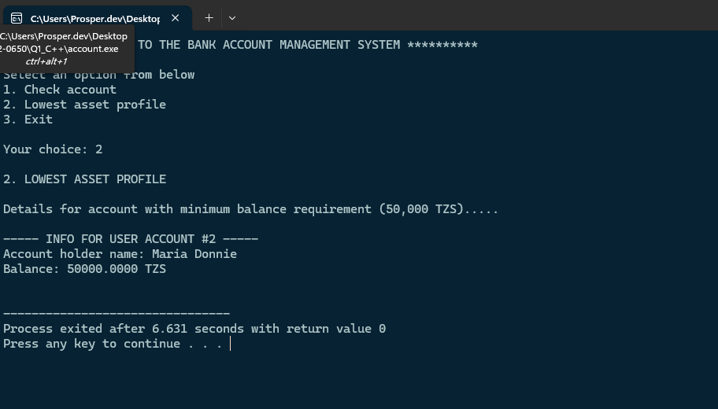

- Selecting the “Exit” option
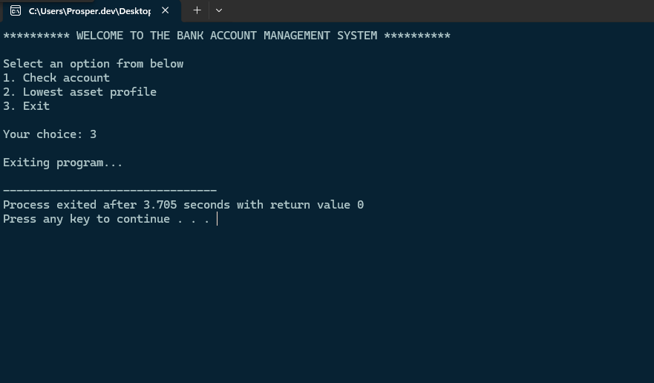

QUESTION 2:
Source code (registration.html)

<!DOCTYPE html>
<html lang=”en”>
<head>
<meta charset=”UTF-8”>
<meta name=”viewport” content=”width=device-width, initial-scale=1.0”>
<title>Student Registration</title>
<link rel=”stylesheet” href=”style.css”>
</head>
<body>
<main class=”main-container”>
<form action=”send.php” id=”register” class=”form-container” method=”post”>
<h1>Student Registration</h1>
<div class=”input-container”>
<label for=”name”>Student Name</label>
<input type=”text” id=”name” name=”name” required>
</div>

<div class=”input-container”>
<label for=”regNumber”>Registration Number</label>
<input type=”text” id=”regNumber” name=”regNumber” required>
</div>

<div class=”input-container”>
<label for=”gender”>Gender</label>
<select id=”gender” name=”gender”>
<option value=”Male”>Male</option>
<option value=”Female”>Female</option>
</select>
</div>

<div class=”input-container”>
<label for=”age”>Age</label>
<input type=”number” id=”age” name=”age” required>
</div>

<button type=”submit”>Register</button>
</form>
</main>
</body>
</html>

Index Number: S4692/0650

Source code (send.php):

<?php

$hostname = "localhost";
$username = "root";
$password = "";
$database = "school_db";

$connection = new mysqli($hostname, $username, $password, $database);

// Test the connection
if ($connection->connect_error) {
die("Failed to connect to database!\n" . $connection->connect_error);
} else {
echo "Connected to database successfully!";
}

// Retrieve the respective input values from the form
$student_name = $_POST["name"];
$reg_no = $_POST["regNumber"];
$gender = $_POST["gender"];
$age = (int) $_POST["age"];

// Prepare and execute the query
$sql = $connection->prepare(
"INSERT INTO `students` VALUES (?, ?, ?, ?)"
);

$sql->bind_param("sssi", $student_name, $reg_no, $gender, $age);

if ($sql->execute()) {
echo "Successfully inserted user into database `student_db`";
} else {
echo "Could not execute query.";
}

?>

Index Number: S4692/0650

Source code (styles.css):
*, *::after, *::before {
margin: 0;
box-sizing: border-box;
}

body {
background-color: #f2f2f2;
font-family: Arial;
}

.main-container {
display: flex;
flex-direction: column;
align-items: center;
padding-top: 5rem;
}

.form-container {
width: 400px;
background-color: white;
padding: 25px;
border: 2px solid;
border-radius: 10px;
box-shadow: 5px 5px #ccc;
}

.form-container label, input {
display: block;
}

.form-container input {
width: 100%;
height: 30px;
border: 0.5px solid #ccc;
border-radius: 5px;
}

h1 {
margin-bottom: 1rem;
text-align: center;
}

.input-container {
margin-bottom: 1rem;
}

.input-container select {
width: 100%;
height: 30px;
border: 0.5px solid #ccc;
border-radius: 5px;
}

.form-container button {
width: 100%;
background-color: green;
color: white;
padding: 0.8rem;
border-style: none;
border-radius: 5px;
margin-top: 1rem;
cursor: pointer;
}

Source code (create_db.sql):
CREATE DATABASE student_db;

USE student_db;

CREATE TABLE students(
student_id INT PRIMARY KEY AUTO_INCREMENT,
name VARCHAR(100),
reg_no VARCHAR(30),
gender VARCHAR(10),
age INT
);

Index Number: S4692/0650

Screenshots:
- Registration to the webpage
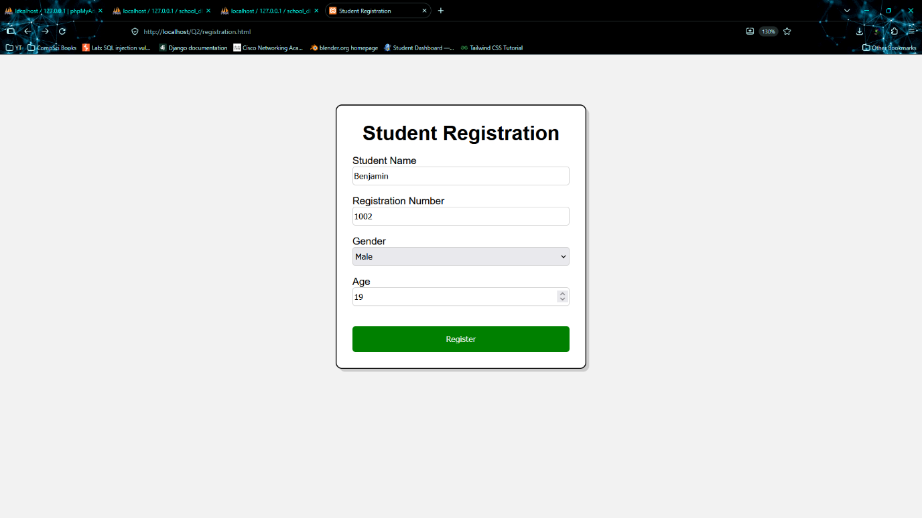

- Creating the student_db database table `students` using phpMyAdmin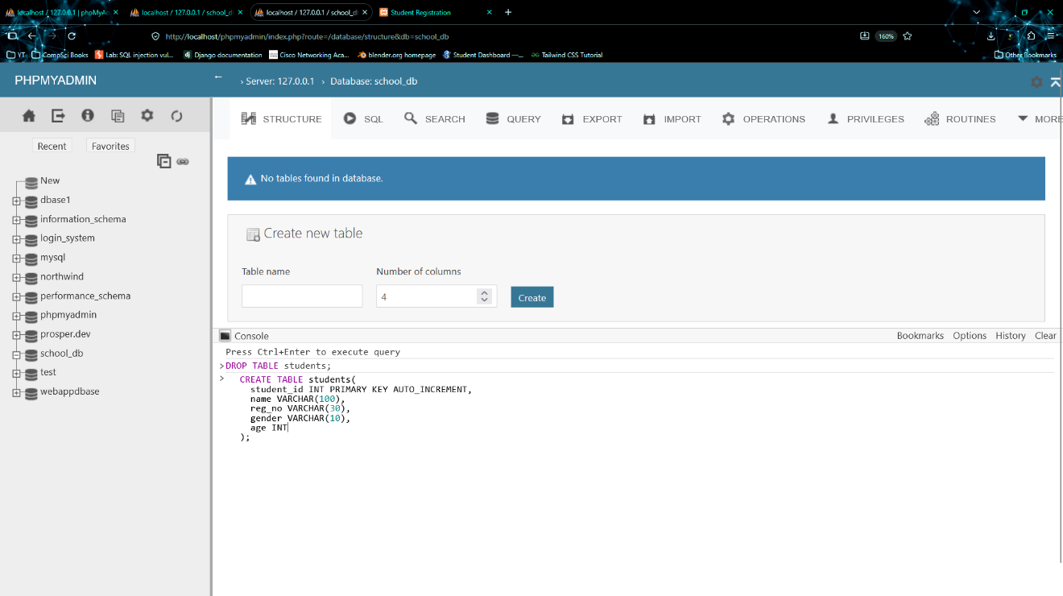

- Successful connection to the database
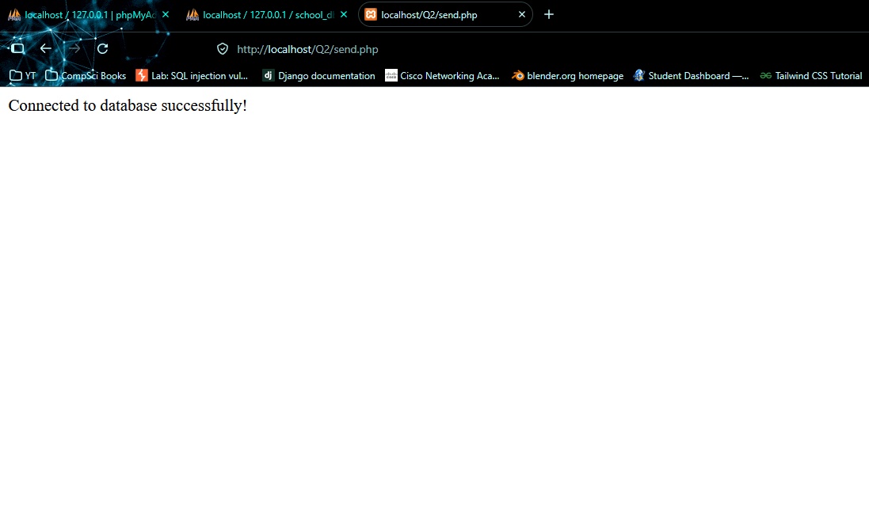

Index Number: S4692/0650

